Making an LED Blink using Analogue Input
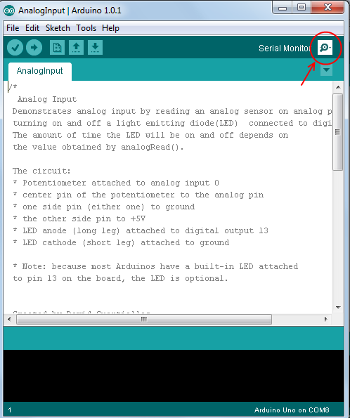
- Create the circuit shown on last page
- Open the Arduino IDE program on your computer
- In the menu at the top of the arduino program go to
File → Examples → 03.Analog → AnalogInput
- Change the code to look like the program code below, you should have to add two lines
- Upload the code to the arduino
- Turn the potentiometer and the light should blink either faster or slower
- Open up the serial monitor (see picture to right)
- Make sure that the bottom right box in the Serial Monitor is set to 9600 baud
- You should see values between 1 and 1023 appearing on the screen, turn the potentiometer, the value should change. This value is the value we stored in the variable sensorValue and is the value that we are reading from the potentiometer.
Extensions

- Create a two or three LED circuit with the potentiometer connected and when the value of potentiometer is above 500, LED 1 is on otherwise LED 2 is on. Here is a hint for the code:
if(sensorValue > 500){
//Code in here is run when sensorValue > 500 is correct, so any value bigger //than 500
}else{
//Code in here is run when sensorValue > 500 is wrong, so any value less //than 500 or 500 itself
}

More about the 'if' statement
Its General form is below:
if(Statement){
Code here is run when statement is true/correct
}else{
Code here is run when statement is false/wrong
}
The else bit is optional so we could just have:
if(Statement){
Code here is run when statement is true/correct
}

Statement is something that is either true or false for example:
5 > 3 is true
sensorValue < 200 is false if variable 'sensorValue' has value 305

We can use the following operators in a statement
A == B | True only if A and B are the same
A > B | True if A is greater than B
A < B | True if A is less than B
A != B | True only if A is not the same as B

Program Code (File → Examples → 03.Analog → AnalogInput)
int sensorPin = A0; // select the input pin for the potentiometer
int ledPin = 13; // select the pin for the LED
int sensorValue = 0; // variable to store the value coming from the sensor
This line tells the arduino that we want to send text to the computer, without it Serial.println() wouldn't do anything
void setup() {
// declare the ledPin as an OUTPUT:
pinMode(ledPin, OUTPUT);
Serial.begin(9600); //<------------ ADD THIS LINE
}

void loop() {
// read the value from the sensor:
This line allows you to send text to our computer and it will be displayed in the Serial Monitor. Here we are sending the value contained in the variable 'sensorValue'.
sensorValue = analogRead(sensorPin);
Serial.println(sensorValue) //<------------ ADD THIS LINE
// turn the ledPin on
digitalWrite(ledPin, HIGH);
// stop the program for <sensorValue> milliseconds:
delay(sensorValue);
// turn the ledPin off:
digitalWrite(ledPin, LOW);
// stop the program for for <sensorValue> milliseconds:
delay(sensorValue);
}
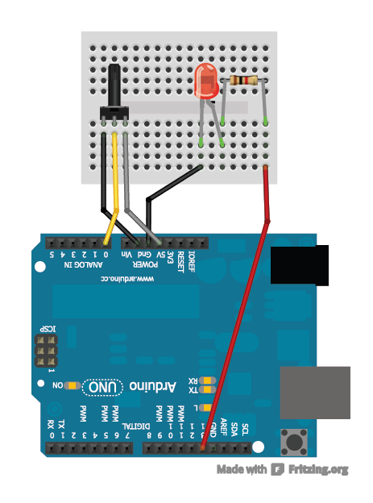
Circuit Diagram
1K ohm Resistor
Called a potentiometer

